1. C Code for MINIMUM SPANNING TREE

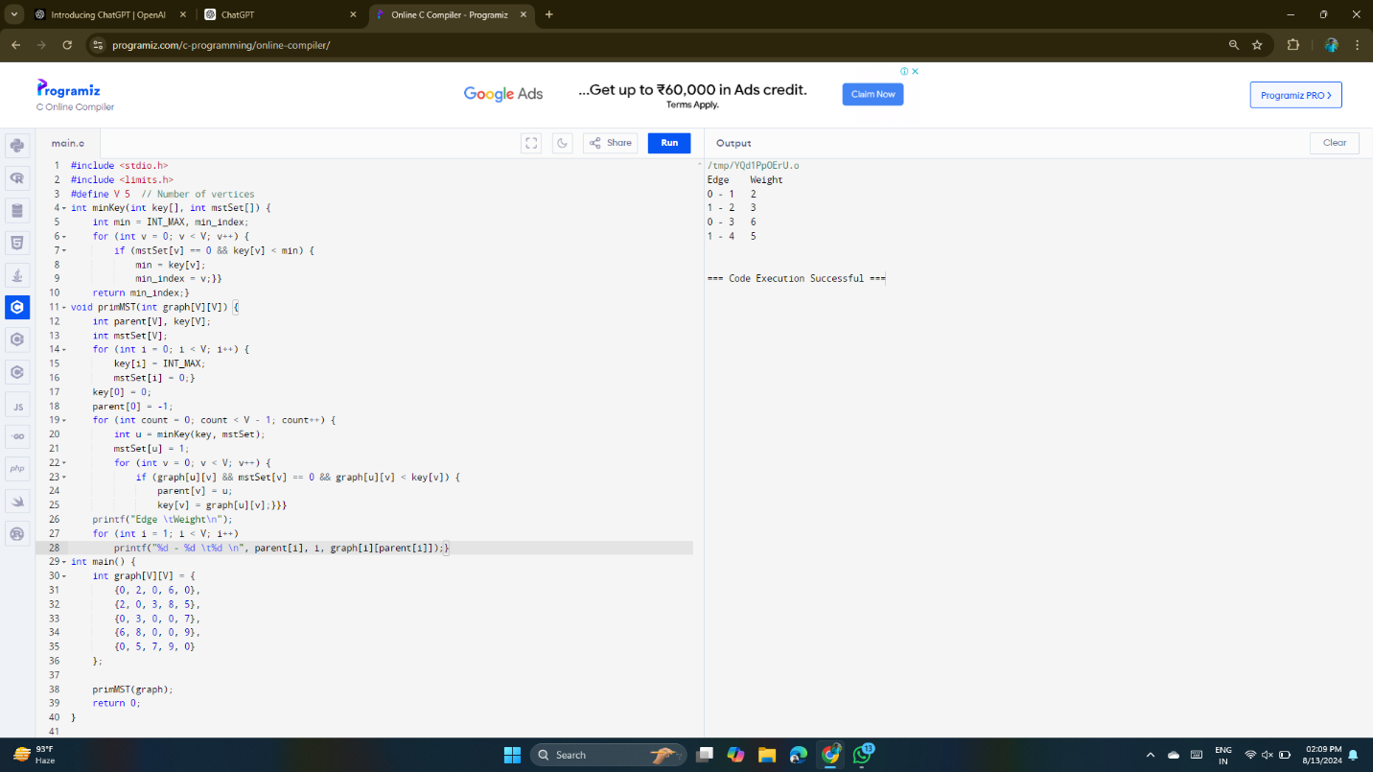

1. C Code for PRIMS ALGORITHM

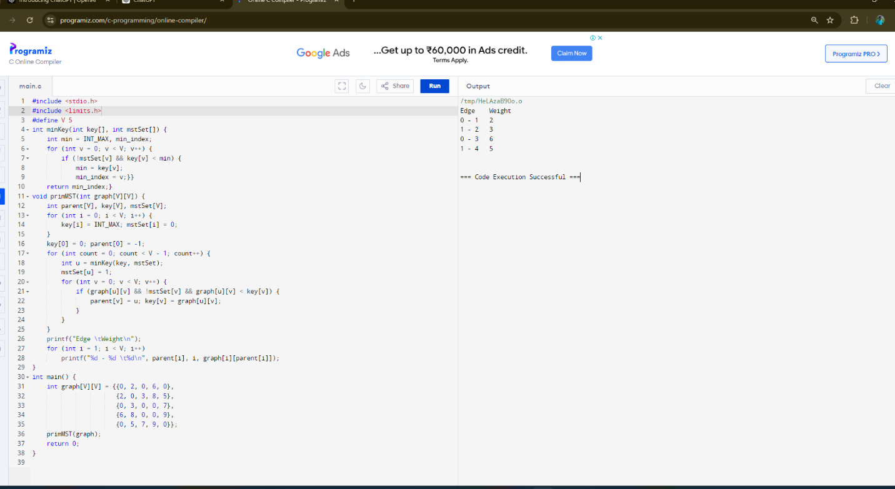

1. C Code for KRUSHKAL ALGORITHM

